IOT BASED SMART CROP PROTECTION SYSTEM

FOR AGRICULTURE

**NAALAIYA THIRAN PROJECT BASED LEARNING ON PROFESSIONAL READINESS FOR INNOVATION, EMPLOYABILITY**

**AND ENTREPRENEURSHIP**

**A PROJECT REPORT**

|  |  |
| --- | --- |
| **SHOBANA SRI M** | **611819106048** |
| **VEDHA PRIYA K M** | **611819106059** |
| **JAYA SRI G** | **611819106014** |
|  |  |

**TEAM ID** : PNT2022TMID40963

**FACULTY MENTORS NAME** : L.PRAKASM

**INDUSRTY MENTORS NAME** : DINESH

**EVALUATOR NAME :** S. SHANMUGAM

**P.S.V. COLLEGE OF ENGINEERING AND TECHNOLOGY**

**(An ISO 9001:2015 Certified Institution)**

**(Accredited by NAAC with ‘A’ Grade)**

**KRISHNAGIRI-635108**

**NOVEMBER 2022**

ANNA UNIVERSITY: CHENNAI 600 025

**SIGNATURE SIGNATURE**

**Prof. C.THAMILARSI.,M.E., Prof. L.PRKASAM.,M.E.,**

**Head of the Department Faculty Mentor,**

Dept of ECE, Dept of ECE,

P.S.V.College of P.S.V.College of

Engineering & Technology, Engineering & Technology,

Krishnagiri-635 108. Krishnagiri-635 108.

Submitted for the **Naalaiya Tiran Project based learning on professional readiness for Innovation, Employability and Entrepreneurship** held on ……………….……………….at P.S.V College of Engineering and Technology, Krishnagiri.

**INTERNAL EXAMINAR EXTERNAL EXAMINAR**

**TABLE OF CONTENTS**

**CHAPTER NO. TITLE**

**1. INTRODUCTION**

1.1 Project Overview

1.2 Purpose

**2. LITERATURE SURVEY**

2.1 Existing problem

2.2 References

2.3 Problem Statement Definition

**3. IDEATION & PROPOSED SOLUTION**

3.1 Empathy Map Canvas

3.2 Ideation & Brainstorming

3.3 Proposed Solution

3.4 Problem Solution fit

**4. REQUIREMENT ANALYSIS**

4.1 Functional requirement

4.2 Non-Functional requirements

**5. PROJECT DESIGN**

5.1 Data Flow Diagrams

5.2 Solution & Technical Architecture

**6. PROJECT PLANNING & SCHEDULING**

6.1 Sprint Planning & Estimation

6.2 Sprint Delivery Schedule

**7. CODING & SOLUTIONING**

**9. RESULTS**

**10. ADVANTAGES & DISADVANTAGES**

**11. CONCLUSION**

**SMART FARMING**

**ABSTRACT**

Agriculture is the source of living of majority Indians and it also has a countless influence on economy of the country. The objective of our project is to reduce this manual involvement by the farmer by using an automated irrigation system which purpose is to enhance water use for agricultural crops. This paper presents the design and implementation of wireless sensor network that can monitor the air temperature, Humidity, light intensity in a crop field and from remote places also. The system consists of nodes, which are equipped with small size application specific sensors and radio frequency modules. The inspiration for this project came from the countries where economy is based on agriculture and the climatic conditions prime to shortage of rains & scarcity of water. The farmers working in the farm lands are only dependent on the rains and bore wells for irrigation of the land. Even if the farm land has a water-pump, manual involvement by farmers is required to turn the pump on/off when needed. The project is intended to cultivate an automatic irrigation system which controls the pump motor ON/OFF on sensing the moisture content of the soil. In the field of agriculture, use of appropriate technique of irrigation is essential. The advantage of using this technique is to reduce human intervention and still certify proper irrigation. A software application was developed by predetermining the threshold values of soil moisture, temperature and water level that was programmed into an arm controller. This paper presents the controlling and monitoring the level of water and detecting the soil moisture content.

**CHAPTER-1**

**PROJECT OVERVIEW**

As we know that Indian economy is one of the largest developing economies of the world. The agricultural sector has its largest contribution in the Indian economy. To achieve maximum utilization of man power and to obtain maximum profit in a given stipulated there is a need in the upgradation of various engineering techniques that are being used today. Thus maintaining proper amount of water level in the soil is one of the necessary requirements to harvest a good crop that can be a source of various types of nutrients whether micro or macro for their proper growth. If we talk about Indian farmers they are worst hit by the famines that occurs due to failure of crops depending upon various drought factors. Rain plays the key role in deciding the future of these crops as well as the farmers every year. The over utilization of ground water has drastically reduced the ground water level in the last 15 years. So it is the need of hour to utilise each and every drop of water wisely so that it can also be used by our coming generations also. Also we should develop some new methods that use the renewable sources of energy. The development of these new techniques are going to reach our goal of sustainable development as well as to cut off the emission of greenhouse gases to a minimum level. As the name of our project that is AUTOMATIC IRRIGATION SYSTEM with the help of the Solar power is a step to utilise some new engineering techniques. This technique will be a very good option for the small and medium farmers who suffer every year just because of failure of crops that took place every year. The implementation of this technology has a wide scope in the nearby future.

### PURPOSE

The main objective of this project was to design a small scale irrigated system that would use water in more well-organized way in order to prevent excess water loss and minimize the cost of labor.The following aspects were considered in the choice of design solution

* Installation cost
* Water saving
* Human intervention
* Reliability
* Power consumption
* Maintenance
* Expandability

A critical Consideration in the segment costs, since cost define the viability and feasibility of a project. The water saving was also an important feature, since there is demand to decrease

**CHAPTER-2**

**LITERATURE SURVEY**

### INTRODUCTION

About 58% of Indians rely mostly on agriculture for their livelihood. A significant portion of the Indian economy, accountingfor 17% of GDP, is the agricultural sector. 60% of the population is employed in agriculture. However, farmers are suffering significant losses as a result of a variety of weather changes and animal interference. Farmers use a variety of conventional techniques, such as scarecrows, electric fences, etc. In some places, farmers burn elephant dung or other items that produce thick smoke to keep their farmland from being destroyed. In some places, people also use castor oil, a natural emulsion of fish or garlic, or both to ward off animals. However, they are not very good at keeping animals away from farms. Consequently, we created this affordable system to surveillance and to protect the farm effectively.

### IOT Based Smart Agriculture System ABSTARCT

In today materialistic society, smart agriculture systems are a hot topic. This essay explains the idea of showcasing and maintaining an online agribusiness platform. The most crucial aspect of human life is agriculture, which may be improved utilising IoT technology. IoT technology makes it possible to increase the effectiveness of agricultural automation systems. Smart agriculture system that makes use of the benefits of cutting-edge technology like Wireless Sensor Network and Arduino. In order to increase crop productivity, this paper offers the idea and features of the sensor world in the

internet of things for agriculture. The agriculture stick that is being suggested in this study integrates Arduino technology, a breadboard, and a variety of sensors, and a live data feed may be accessed online using a mobile phone. The construction of a system that can track temperature, humidity, moisture, and even the movement of animals that can destroy crops in agricultural fields using sensors and an Arduino board is a feature of this study. The device has the

potential to be helpful in water-scarce, remote places thanks to its low cost and energy independence.

### ADVANTAGES

* + Efficiency, Expansion, Reduced resources.
  + Clean process, Agility, Improved product quality**.**

### Smart Crop protection system from living objectsand fire using Arduino

**ABSTARCT**

Farmers can no longer block entire fields or prepare a field for 24 hours of protection. Therefore, we are presenting this computerised crop safety system against fire and animals. This is a microcontroller- based device that is mostly based on the Arduino Uno. This method uses a motion sensor to find animals approaching the sphere and a smoke sensor to find the hearth. The sensor informs the microcontroller to take action in such a situation. The microcontroller now sounds an alert to further entice the animals away from the area while also calling the farmer and sending an SMS so that he can understand the situation and visit the scene in case the animals don'tgo despite the noise. If smoke is detected, it quickly turns the motor ON.

### ADVANTAGES

Reduce waste, improve productivity and enable management ofa greater number of resources through remote sensing

### Development of IOT based Smart Security andMonitoring Devices

**for Agriculture:**

ABSTARCT

Since agriculture is the foundation of the Indian economy, it demands protection. Agriculture products need protection and safety at a very early stage, such as protection from rodent or insect attacks in fields or grain storage, and security is no longer just a matter of sources. Even so, these difficulties should be taken into account. Today's security systems don't seem to be intelligent enough to send out real-time notifications when they detect a problem. Agriculture can become more modernised by combining traditional methods with current technologies like wireless sensor networks and the internet of things. With this situation in mind, we developed, tested, and examined a "Internet of Things"-based device that can analyse the sensed data before transferring it to the user. This device will be operated and monitored from a remote location, and it is used in grain bins, bloodless stores, and agricultural fields for security reasons. This study aims to improve ways for resolving issues such rodent identification, crop hazards, and turning in real-time notifications backed records evaluation and processing in addition to humanintervention. The sensors and digital units used in this gadget are integrated using Python programmes. With support from attempted test cases, we were successful in 84.8% of test cases.

### Development of IOT based Smart Security andMonitoring Devices

**for Agriculture:**

### ABSTARCT

Since agriculture is the foundation of the Indian economy, it demands protection. Agriculture products need protection and safety at a very early stage, such as protection from rodent or insect attacks in fields or grain storage, and security is no longer just a matter of sources. Even so, these difficulties should be taken into account. Today's security systems don't seem to be intelligent enough to send out real-time notifications when they detect a problem. Agriculture can become more modernised by combining traditional methods with current technologies like wireless sensor networks and the internet of things. With this situation in mind, we developed, tested, and examined a "Internet of Things"-based device that can analyse the sensed data before transferring it to the user. This device will be operated and monitored from a remote location, and it is used in grain bins, bloodless stores, and agricultural fields for security reasons. This study aims to improve ways for resolving issues such rodent identification, crop hazards, and turning in real-time notifications backed records evaluation and processing in addition to humanintervention. The sensors and digital units used in this gadget are integrated using Python programmes. With support from attempted test cases, we were successful in 84.8% of test cases.

### CONCLUSION

In India, farmers frequently suffer significant losses as a result of animals. In order to solve this problem, a system was created that emits a frightening sound, causing animals to flee immediately. The main goal is to avoid crop loss and to safeguard the land from trespassers and wild animals, both of which pose a serious threat to agricultural areas. To notify the farmer, a call is placed using the GSM module. As a result, the developed method is cost-effective and beneficial to farmers. The system is safe for people and animals to use, and also safeguards farmland. With IOT monitoring, the system is able to protect the farm day and night.

### REFERENCE

P Rekha, T. Saranya, P. Preethi, L. Saraswathi, G. Sobhana "Smart Agro Using Arduino and GSM" International Journal of Emerging Technologies in Engineering Research Vol: 5, ssue: 3March, 2017.

Tejas Khare, Anuradha Phadke “Automated Crop Field Surveillance Using Computer Vision” Conference Paper, Dec 2020

Damini Kalra, Praveen Kumar, K. Singh, Apurva Soni “Sensor Based Crop Protection System with IoT monitored Automatic Irrigation” 2nd International conference on Advances in Computing,Communication Control and Networking, 2020.

S. Giordano, Ilias Nektarios Seitanidis, Mike Oluwatayo Ojo, Davide Adami “IoT solutions for crop protection against wild animal attacks” 2018 IEEE International Conference on Environmental Engineering (EE), March 2018

### CHAPTER - 3 REQUIREMENT ANALYSIS

**FUNCTIONAL REQUIREMENTS**

Following are the functional requirements of the proposed solution.

|  |  |  |
| --- | --- | --- |
| **FR No** | **Functional**  **Requirement (Epic)** | **Sub Requirement**  **(Story / Sub-Task)** |
| **FR-1** | User registration | Download the app Registration through GmailCreate an account  Follow the instructions |
| **FR-2** | User Confirmation | Confirmation via Email Confirmation via  OTP |
| **FR-3** | Sensors | Sensors is used to monitor and control the crop from insects or animals or other environmental conditions. Then send  the data to the processor. |
| **FR-4** | Smart irrigation | Using an irrigation system helps to soil maintenance moisture  and protect the soil from |

|  |  |  |
| --- | --- | --- |
|  |  | Drying out |
| **FR-5** | Accessing datasets | Datasets are retrieved  From Cloudant DB |
| **FR-6** | Cloud | Data storing for the information about the crops. |
| **FR-6** | Mobile application | Motos and sprinklers in the field  can be controlled by mobile application. |

### NON-FUNCTIONAL REQUIREMENTS:

The non-functional requirements for the suggested solution are listed below.

|  |  |  |
| --- | --- | --- |
| **FR No** | **Non-Functional Requirement** | **Description** |
| **NFR-1** | Usability | The project's contribution to farm protection is demonstrated through the  smart protection system. |
| **NFR-2** | Security | This project was created to protect the crops from animals |
| **NFR-3** | Reliability | With the help of this technology, farmers will be able to safeguard their lands and avoid suffering substantial financial losses. They will also benefit  from higher crop yields,  which will improve their economic situation. |
| **NFR-4** | Performance | When animals attempt to enter the field, IOT devices and sensors alert the farmer via message. We also utilise an SD card  module that helps to store a specific sound to frighten the |

|  |  |  |
| --- | --- | --- |
|  |  | animals. |
| **NFR-5** | Availability | We can defend the crops against wild animals by creating and implementing  resilient hardware and software. |
| **NFR-6** | Scalability | Since IBM Cloudant services integratedwith ion methods aid effectively  retrieve enormous quantities of  photos,thus strengthening scalability |

**CHAPTER - 4 PROJECT DESIGN**

**DATA FLOW DIAGRAMS**

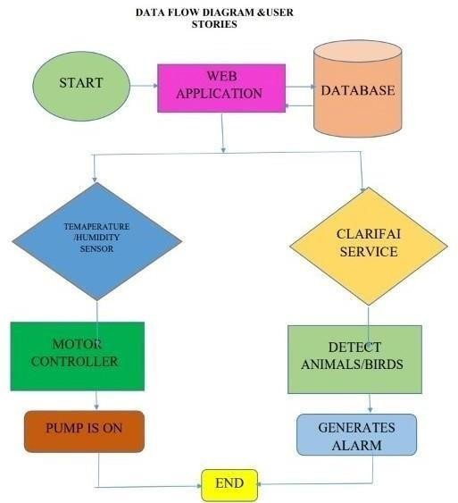

**4.1 SOLUTION & TECHNICAL ARCHITECTURE**

### Solution Architecture:

The PIR sensor, web camera, ultrasonic sensor, LDR sensor, temperature sensor, humidity sensor, moisture sensor, buzzer, and monitor are all utilised in the system. Using various sensors, the various soil parameters (temperature, humidity, light intensity, pH level) are measured, and the results are saved in the IBM cloud. If there was a change in the evaluation threshold, the sensors would send an alert to the farmer's mobile device or web page. This would ensure that the plants were completely protected from both animals and environmental conditions, preventing the farmer from suffering loss. To process weather data from a weather API as well as data from sensors, an Arduino Uno is used as a processing unit. To connect the hardware, software, and APIs, Node Red is utilised as a programming tool. It uses the MQTT protocol for communication. System that is built for monitoring the crop field with the help of sensor. The IOT device is used to indicate The farmer by a message while someone enter into the Farm and we are used SD card module that helps to Store a specified sound to fear the animals. The announcement of the threshold rate will be sent to the cell number or to the website. The result will be generated on a catalog if the mobile of the person to take the necessary action.

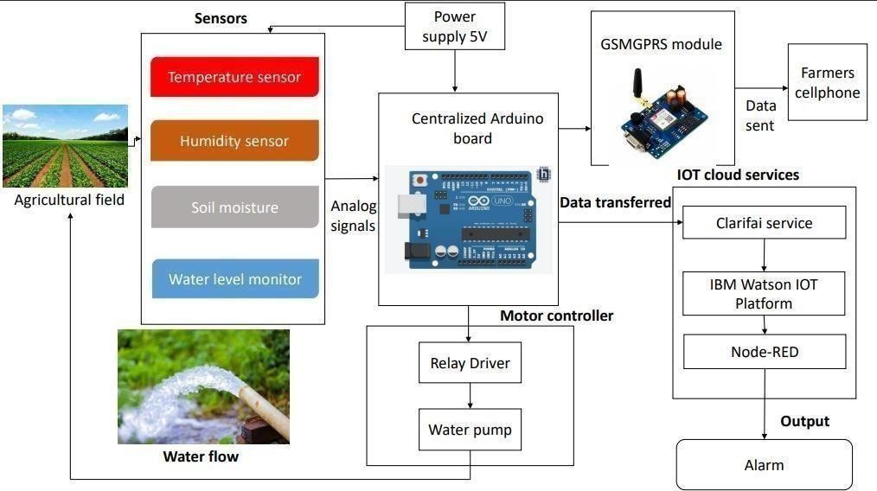

**TECHNICAL ARCHITECTURE:**

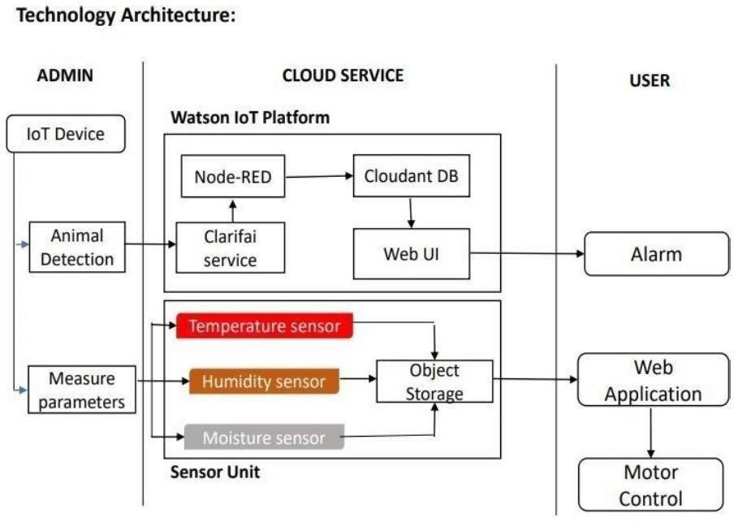

### MODULE 1

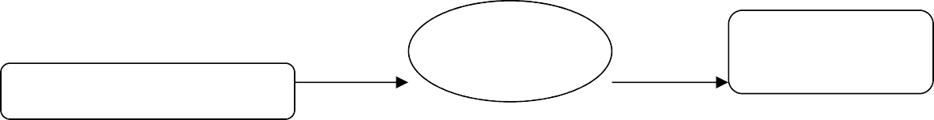

IOT

MODLUE

CLOUD

CONTROLLER

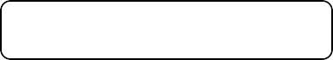

AGRI SENSOR ARRAY

The Internet of things refers to a type of network to connect anything with the Internet based on stipulated protocols through information sensing equipments to conduct information exchange and communications in order to achieve smart recognitions, positioning, tracing, monitoring, and administration. In this paper we briefly discussed about what IOT is, how IOT enables different technologies, about its architecture, characteristics & applications, IOT functional view & what are the future challenges for IOT.

Internet of Things is a new revolution of the Internet. Objects make themselves recognizable and they obtain intelligence by making or enabling context related decisions thanks to the fact that they can communicate information about themselves. They can access information that has been aggregated by other things, or they can be components of complex services. This transformation is concomitant with the emergence of cloud computing capabilities and the transition of the Internet towards IPv6 with an almost unlimited addressing capacity

### MODULE 2

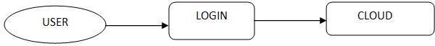

Today we are going to build a registration system that keeps track of which users are admin and which are normal users. The normal users in our application are not allowed to access admin pages. All users (Admins as well as normal users) use the same form to login. After logging in, the normal users are redirected to the index page while the admin users are redirected to the admin pages.

### MODULE 3

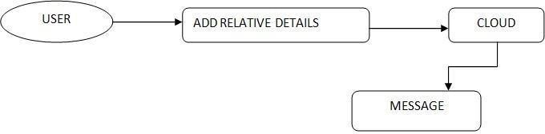

Smart phones are basic needs of our daily life. It’s like a small computer which gives you many facilities such as web browsing, downloading and many more but small data storage space and backup are major problem. On the other hand cloud computing provides efficient computational resources and secure data hosting services. But the data transmission among two secure networks is performed over unsecured network. So need a design to secure data transfer.

**CHAPTER-5**

**HARDWARE AND SOFTWARE REQUIREMENT HARDWARE REQUIREMENT**

Hardware details:

* IOT Module
* Agri sensors
* Arduino controller
* Power supply
* Lcd display
* CPU type : Intel Pentium 4
* Clock speed : 3.0 GHz
* Ram size : 512 MB
* Hard disk capacity : 40 GB
* Monitor type : 15 Inch color monitor
* Keyboard type : internet keyboard Software details:
* Proteus
* Arduino studio
* My sql
* Dreamweaver
* Operating System : Windows OS,WAMP server
* Language : PHP, Embedded c

### AVR

The **AVR** is a modified Harvard architecture 8-bit RISC single- chip microcontroller, which was developed by Atmel in 1996. The AVR was one of the first microcontroller families to use on-chip flash memory for program storage, as opposed to one-time programmable ROM,EPROM, or EEPROM used by other microcontrollers at the time.

The AVR is a modified Harvard architecture machine, where program and data are stored in separate physical memory systems that appear in different address spaces, but having the ability to read data items from program memory using special instructions.

### Basic families

AVRs are generally classified into following:

**Tiny AVR** — the A Ttiny series

* 0.5–16 kB program memory
* 6–32-pin package
* Limited peripheral set

**Mega AVR** — the AT mega series

* 4–512 kB program memory
* 28–100-pin package
* Extended instruction set (multiply instructions and instructions for handling larger program memories)
* Extensive peripheral set

**XMEGA** — the AT x mega series

* 16–384 kB program memory
* 44–64–100-pin package (A4, A3, A1)
* Extended performance features, such as DMA, "Event System", and cryptography support.
* Extensive peripheral set with ADCs

### Application-specific AVR

* Mega AVRs with special features not found on the other members of the AVR family, such as LCD controller, USB controller, advanced PWM, CAN, etc.

### FPSLIC (AVR with FPGA)

* FPGA 5K to 40K gates
* SRAM for the AVR program code, unlike all other AVRs
* AVR core can run at up to 50 MHZ

### 32-bit AVRs

In 2006 Atmel released microcontrollers based on the 32-bit AVR32 architecture. They include SIMD and DSP instructions, along with other audio- and video- processing features. This 32-bit family of devices is intended to compete with the ARM-based processors. The instruction set is similar to other RISC cores, but it is not compatible with the original AVR or any of the various ARM cores.

### Device architecture

Flash, EEPROM, and SRAM are all integrated onto a single chip, removing the need for external memory in most applications. Some devices have a parallel external bus option to allow adding additional data memory or memory-mapped devices. Almost all devices (except the smallest TinyAVR chips) have serial interfaces, which can be used to connect larger serial EEPROMs or flash chips.

### Program memory

Program instructions are stored in non-volatile flash memory. Although the MCUs are 8-bit, each instruction takes one or two 16-bit words.

The size of the program memory is usually indicated in the naming of the device itself (e.g., the ATmega64x line has 64 kB of flash, while the ATmega32x line has 32 kB).

There is no provision for off-chip program memory; all code executed by the AVR core must reside in the on-chip flash. However, this limitation does not apply to the AT94 FPSLIC AVR/FPGA chips.

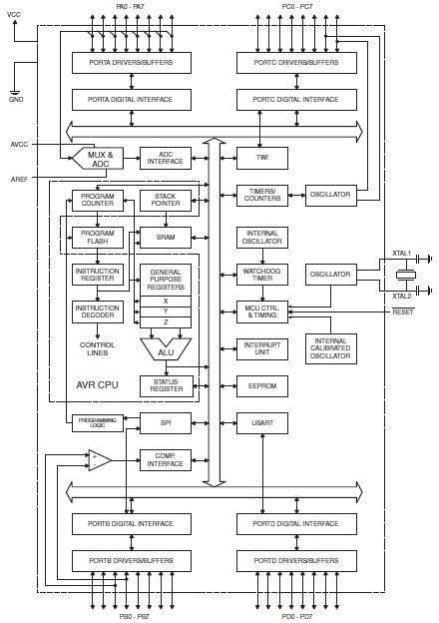

### Internal data memory

The data address space consists of the register file, I/O registers, and SRAM.

### Internal registers

The AVRs have 32 single-byte registers and are classified as 8-bit RISC devices.

In the tiny AVR and mega AVR variants of the AVR architecture, the working registers are mapped in as the first 32 memory addresses (000016–001F16), followed by 64 I/O registers (002016–005F16). In devices with many peripherals, these registers are followed by 160 “extended I/O” registers, only accessible as memory-mapped I/O (006016–00FF16).

Actual SRAM starts after these register sections, at address 006016 or, in devices with “extended I/O”, at 010016.

Even though there are separate addressing schemes and optimized opcodes for accessing the register file and the first 64 I/O registers, all can still be addressed and manipulated as if they were in SRAM.

The very smallest of the tiny AVR variants use a reduced architecture with only 16 registers (r0 through r15 are omitted) which are not addressable as memory locations. I/O memory begins at address 000016, followed by SRAM. In addition, these devices have slight deviations from the standard AVR instruction set. Most notably, the direct load/store instructions (LDS/STS) have been reduced from 2 words (32 bits) to 1 word (16 bits), limiting the total direct addressable memory (the sum of both I/O and SRAM) to 128 bytes. Conversely, the indirect load instruction's (LD) 16-bit address space is expanded to also include non-volatile memory such as Flash and configuration bits; therefore, the LPM instruction is unnecessary and omitted.

In the XMEGA variant, the working register file is not mapped into the data address space; as such, it is not possible to treat any of the XMEGA's working registers as though they were SRAM. Instead, the I/O registers are mapped into the data address space starting at the very beginning of the address space. Additionally, the amount of data address space dedicated to I/O registers has grown substantially to 4096 bytes (000016–0FFF16). As with previous generations, however, the fast I/O manipulation instructions can only reach the first 64 I/O register locations (the first 32 locations for bitwise instructions). Following the I/O registers, the XMEGA series sets aside a 4096 byte range of the data address space, which can be used optionally for mapping the internal EEPROM to the data address space (100016– 1FFF16). The actual SRAM is located after these ranges, starting at 200016.

### GPIO ports

Each GPIO port on a tiny or mega AVR drives up to eight pins and is controlled by three 8-bit registers: DDRx, PORTx and PINx, where x is the port identifier.

* DDRx: Data Direction Register, configures the pins as either inputs or outputs.
* PORTx: Output port register. Sets the output value on pins configured as outputs. Enables or disables the pull-up resistor on pins configured as inputs.
* PINx: Input register, used to read an input signal. On some devices (but not all, check the datasheet), this register can be used for pin toggling: writing a logic one to a PINx bit toggles the corresponding bit in PORTx, irrespective of the setting of the DDRx biT

X mega AVR have additional registers for push/pull, totem-pole and pullup configurations.

### EEPROM

Almost all AVR microcontrollers have internal EEPROM for semi-permanent data storage. Like flash memory, EEPROM can maintain its contents when electrical power is removed.

In most variants of the AVR architecture, this internal EEPROM memory is not mapped into the MCU's addressable memory space. It can only be accessed the same way an external peripheral device is, using special pointer registers and read/write instructions, which makes EEPROM access much slower than other internal RAM.

However, some devices in the Secure AVR (AT90SC) family use a special EEPROM mapping to the data or program memory, depending on the configuration. The XMEGA family also allows the EEPROM to be mapped into the data address space.

Since the number of writes to EEPROM is not unlimited — Atmel specifies 100,000 write cycles in their datasheets — a well designed EEPROM write routine should compare the contents of an EEPROM address with desired contents and only perform an actual write if the contents need to be changed.

Note that erase and write can be performed separately in many cases, byte-by-byte, which may also help prolong life when bits only need to be set to all 1s (erase) or selectively cleared to 0s (write).

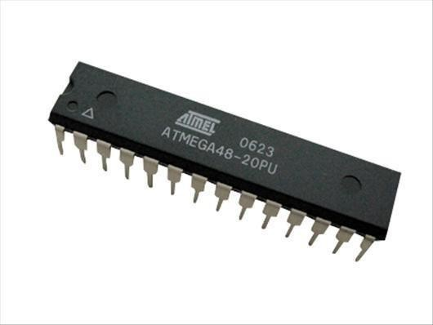

### Program execution

FIG NO: ATMEGA8A

Atmel's AVRs have a two-stage, single-level pipeline design. This means the next machine instruction is fetched as the current one is executing. Most instructions take just one or two clock cycles, making AVRs relatively fast among eight- bit microcontrollers.

The AVR processors were designed with the efficient execution of compiled C code in mind and have several built-in pointers for the task.

### Instruction set

The AVR instruction set is more orthogonal than those of most eight-bit microcontrollers, in particular the 8051 clones and PIC microcontrollers with which AVR competes today. However, it is not completely regular:

* Pointer registers X, Y, and Z have addressing capabilities that are different from each other.
* Register locations R0 to R15 have different addressing capabilities than register locations R16 to R31.
* I/O ports 0 to 31 have different addressing capabilities than I/O ports 32 to 63.
* CLR affects flags, while SER does not, even though they are complementary instructions. CLR set all bits to zero, and SER sets them to one. (Note that CLR is pseudo-op for EOR R, R; and SER is short for LDI R,$FF. Math operations such as EOR modify flags, while moves/loads/stores/branches such as LDI do not.)
* Accessing read-only data stored in the program memory (flash) requires special LPM instructions; the flash bus is otherwise reserved for instruction memory.

Additionally, some chip-specific differences affect code generation. Code pointers (including return addresses on the stack) are two bytes long on chips with up to 128 k Bytes of flash memory, but three bytes long on larger chips; not all chips have hardware multipliers; chips with over 8 kB of flash have branch and call instructions with longer ranges; and so forth.

The mostly regular instruction set makes programming it using C (or even Ada) compilers fairly straightforward. GCC has included AVR support for quite some time, and that support is widely used. In fact, Atmel solicited input from major developers of compilers for small microcontrollers, to determine the instruction set features that were most useful in a compiler for high-level languages.

### MCU speed

The AVR line can normally support clock speeds from 0 to 20 MHz, with some devices reaching 32 MHZ. Lower-powered operation usually requires a reduced clock speed. All recent (Tiny, Mega, and X mega, but not 90S) AVRs feature an on-chip oscillator, removing the need for external clocks or resonator circuitry. Some AVRs also have a system clock pre scaler that can divide down the system clock by up to 1024. This pre scaler can be reconfigured by software during run- time, allowing the clock speed to be optimized.

Since all operations (excluding multiplication and 16-bit add/subtract) on registers R0–R31 are single-cycle, the AVR can achieve up to 1 MIPS per MHz, i.e. an 8 MHz processor can achieve up to 8 MIPS. Loads and stores to/from memory take two cycles, branching takes two cycles. Branches in the latest "3-byte PC" parts such as ATmega2560 are one cycle slower than on previous devices.

### Development

AVRs have a large following due to the free and inexpensive development tools available, including reasonably priced development boards and free development software. The AVRs are sold under various names that share the same basic core, but with different peripheral and memory combinations. Compatibility between chips in each family is fairly good, although I/O controller features may vary.

### Features

AVRs offer a wide range of features:

* Multifunction, bi-directional general-purpose I/O ports with configurable, built-in pull-up resistors
* Multiple internal oscillators, including RC oscillator without external parts
* Internal, self-programmable instruction flash memory up to 256 kB (384 kB on X Mega)
  + In-system programmable using serial/parallel low-voltage proprietary interfaces or JTAG
  + Optional boot code section with independent lock bits for protection
* On-chip debugging (OCD) support through JTAG or debug WIRE on most devices
  + The JTAG signals (TMS, TDI, TDO, and TCK) are multiplexed on GPIOs. These pins can be configured to function as JTAG or GPIO depending on the setting of a fuse bit, which can be programmed via ISP or HVSP. By default, AVRs with JTAG come with the JTAG interface enabled.
  + debug WIRE uses the /RESET pin as a bi-directional communication channel to access on-chip debug circuitry. It is present on devices with lower pin counts, as it only requires one pin.
* Internal data EEPROM up to 4 kB
* Internal SRAM up to 16 kB (32 kB on X Mega)
* External 64 kB little endian data space on certain models, including the Mega8515 and Mega162.
  + The external data space is overlaid with the internal data space, such that the full 64 kB address space does not appear on the external bus and accesses to e.g. address 010016 will access internal RAM, not the external bus.
  + In certain members of the X Mega series, the external data space has been enhanced to support both SRAM and SDRAM. As well, the data

addressing modes have been expanded to allow up to 16 MB of data memory to be directly addressed.

* + AVRs generally do not support executing code from external memory. Some ASSPs using the AVR core do support external program memory.
* 8-bit and 16-bit timers
  + PWM output (some devices have an enhanced PWM peripheral which includes a dead-time generator)
  + Input capture that record a time stamp triggered by a signal edge
* Analog comparator
* 10 or 12-bit A/D converters, with multiplex of up to 16 channels
* 12-bit D/A converters
* A variety of serial interfaces, including
  + I²C compatible Two-Wire Interface (TWI)
  + Synchronous/asynchronous serial peripherals (UART/USART) (used with RS-232, RS-485, and more)
  + Serial Peripheral Interface Bus (SPI)
  + Universal Serial Interface (USI): a multi-purpose hardware communication module that can be used to implement an SPI I2C or UART interface.
* Brownout detection
* Watchdog timer (WDT)
* Multiple power-saving sleep modes
* Lighting and motor control (PWM-specific) controller models
* CAN controller support
* USB controller support
  + Proper full-speed (12 Mbit/s) hardware & Hub controller with embedded AVR.
  + Also freely available low-speed (1.5 Mbit/s) (HID) bit banging software emulations
* Ethernet controller support
* LCD controller support
* Low-voltage devices operating down to 1.8 V (to 0.7 V for parts with built- in DC–DC up converter)
* Pico Power devices
* DMA controllers and "event system" peripheral communication.
* Fast cryptography support for AES and DES

### POWER SUPPLIES INTRODUCTION

The present chapter introduces the operation of power supply circuits built using filters, rectifiers, and then voltage regulators. Starting with an ac voltage, a steady dc voltage is obtained by rectifying the ac voltage, then filtering to a dc level, and finally, regulating to obtain a desired fixed dc voltage. The regulation is usually obtained from an IC voltage regulator unit, which takes a dc voltage and provides a somewhat lower dc voltage, which remains the same even if the input dc voltage varies, or the output load connected to the dc voltage changes.

A block diagram containing the parts of a typical power supply and the voltage at various points in the unit is shown in fig 19.1. The ac voltage, typically 120 V rms, is connected to a transformer, which steps that ac voltage down to the level for the desired dc output. A diode rectifier then provides a full-wave rectified voltage that is initially filtered by a simple capacitor filter to produce a dc voltage.

This resulting dc voltage usually has some ripple or ac voltage variation. A regulator circuit can use this dc input to provide a dc voltage that not only has much less ripple voltage but also remains the same dc value even if the input dc voltage varies somewhat, or the load connected to the output dc voltage changes. This voltage regulation is usually obtained using one of a number of popular voltage regulator IC units.

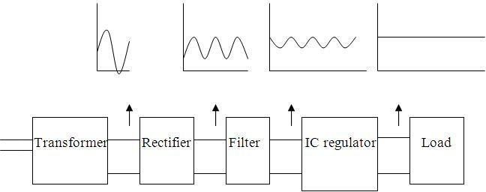

### IC VOLTAGE REGULATORS

Voltage regulators comprise a class of widely used ICs. Regulator IC units contain the circuitry for reference source, comparator amplifier, control device, and overload protection all in a single IC. Although the internal construction of the IC is somewhat different from that described for discrete voltage regulator circuits, the external operation is much the same. IC units provide regulation of either a fixed positive voltage, a fixed negative voltage, or an adjustably set voltage.

A power supply can be built using a transformer connected to the ac supply line to step the ac voltage to desired amplitude, then rectifying that ac voltage, filtering with a capacitor and RC filter, if desired, and finally regulating the dc voltage using an IC regulator. The regulators can be selected for operation with

load currents from hundreds of milles amperes to tens of amperes, corresponding to power ratings from mill watts to tens of watts.

### THREE-TERMINAL VOLTAGE REGULATORS

Fig shows the basic connection of a three-terminal voltage regulator IC to a load. The fixed voltage regulator has an unregulated dc input voltage, Vi, applied to one input terminal, a regulated output dc voltage, Vo, from a second terminal, with the third terminal connected to ground. For a selected regulator, IC device specifications list a voltage range over which the input voltage can vary to maintain a regulated output voltage over a range of load current. The specifications also list the amount of output voltage change resulting from a change in load current (load regulation) or in input voltage (line regulation).

### Fixed Positive Voltage Regulators:

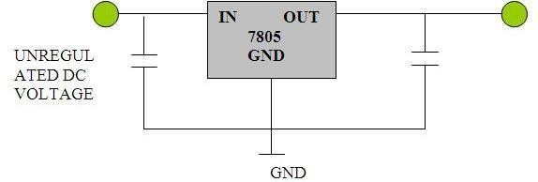

The series 78 regulators provide fixed regulated voltages from 5 to 24 V. Figure 19.26 shows how one such IC, a 7812, is connected to provide voltage regulation with output from this unit of +12V dc. An unregulated input voltage Vi is filtered by capacitor C1 and connected to the IC’s IN terminal. The IC’s OUT terminal provides a regulated + 12V which is filtered by capacitor C2 (mostly for any high-frequency noise). The third IC terminal is connected to ground (GND). While the input voltage may vary over some permissible voltage range, and the output load may vary over some acceptable range, the output voltage remains constant within specified voltage variation limits. These limitations are spelled out in the manufacturer’s specification sheets. A table of positive voltage regulated ICs is provided in table 19.1.

### TABLE 19.1 Positive Voltage Regulators in 7800 series

|  |  |  |
| --- | --- | --- |
| **IC Part** | **Output Voltage (V)** | **Minimum Vi (V)** |
| 7805 | +5 | 7.3 |
| 7806 | +6 | 8.3 |
| 7808 | +8 | 10.5 |
| 7810 | +10 | 12.5 |
| 7812 | +12 | 14.6 |
|  | +15 | 17.7 |

|  |  |  |
| --- | --- | --- |
| 7815 |  |  |
| 7818 | +18 | 21.0 |
| 7824 | +24 | 27.1 |

**MAX 232:**

The **MAX232** is an integrated circuit, first created by Maxim Integrated Products, that converts signals from an RS-232 serial port to signals suitable for use in TTL compatible digital logic circuits. The MAX232 is a dual driver/receiver and typically converts the RX, TX, CTS and RTS signals.

The drivers provide RS-232 voltage level outputs (approx. ± 7.5 V) from a single

+ 5 V supply via on-chip charge pumps and external capacitors. This makes it useful for implementing RS-232 in devices that otherwise do not need any voltages outside the 0 V to + 5 V range, as power supply design does not need to be made more complicated just for driving the RS-232 in this case.

The receivers reduce RS-232 inputs (which may be as high as ± 25 V), to standard 5 V TTL levels. These receivers have a typical threshold of 1.3 V, and a typical hysteresis of 0.5 V.

The later MAX232A is backwards compatible with the original MAX232 but may operate at higher baud rates and can use smaller external capacitors – 0.1 μf in place of the 1.0 μf capacitors used with the original device.

The newer MAX3232 is also backwards compatible, but operates at a broader voltage range, from 3 to 5.5 V

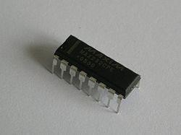

### MAX232 CIRCUIT

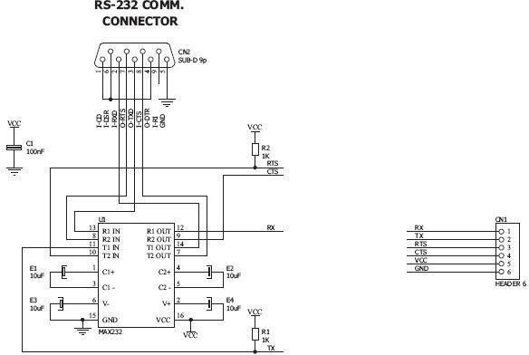

**VOLTAGE LEVEL**

It is helpful to understand what occurs to the voltage levels. When a MAX232 IC receives a TTL level to convert, it changes a TTL Logic 0 to between +3 and

+15 V, and changes TTL Logic 1 to between -3 to -15 V, and vice versa for converting from RS232 to TTL. This can be confusing when you realize that the RS232 Data Transmission voltages at a certain logic state are opposite from the RS232 Control Line voltages at the same logic state. To clarify the matter, see the table below. For more information see RS-232 Voltage Levels.

|  |  |  |
| --- | --- | --- |
| **RS232 Line Type & Logic Level** | **RS232**  **Voltage** | **TTL Voltage to/from MAX232** |
| Data Transmission (Rx/Tx) Logic 0 | +3 V to  +15 V | 0 V |
| Data Transmission (Rx/Tx) Logic 1 | -3 V to -15 V | 5 V |
| Control Signals (RTS/CTS/DTR/DSR) Logic 0 | -3 V to -15 V | 5 V |
| Control Signals (RTS/CTS/DTR/DSR) Logic 1 | +3 V to  +15 V | 0 V |

# SOIL MOISTURE SENSORS

## **Soil moisture sensors** measure the volumetric water content in soil. Since the direct gravimetric measurement of free soil moisture requires removing, drying, and weighting of a sample, soil moisture sensors measure the volumetric water content indirectly by using some other property of the soil, such as electrical resistance, dielectric constant, or interaction with neutrons, as a proxy for the moisture content. The relation between the measured property and soil moisture must be calibrated and may vary depending on environmental factors such as soil type, temperature, or electric conductivity. Reflected microwave radiation is affected by the soil moisture and is used for remote sensing in hydrology and agriculture. Portable probe instruments can be used by farmers or gardeners.

Soil moisture sensors typically refer to sensors that estimate volumetric water content. Another class of sensors measure another property of moisture in soils called water potential; these sensors are usually referred to as soil water potential sensors and include tensiometers and gypsum blocks Measuring soil moisture is important for agricultural applications to help farmers manage their irrigation systems more efficiently.

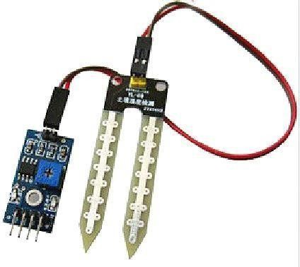

Knowing the exact soil moisture conditions on their fields, not only are farmers able to generally use less water to grow a crop, they are also able to increase yields and the quality of the crop by improved management of soil moisture during critical plant growth stages .In urban and suburban areas, landscapes and residential lawns are using soil moisture sensors to interface with an irrigation controller. Connecting a soil moisture sensor to a simple irrigation clock will convert it into a "smart" irrigation controller that prevents irrigation cycles when the soil is already wet, e.g. following a recent rainfall event. Golf courses are using soil moisture sensors to increase the efficiency of their irrigation systems to prevent over-watering and leaching of fertilizers and other chemicals into the ground.

### TEMPERATURE SENSORS

Temperature sensors are vital to a variety of everyday products. For example, household ovens, refrigerators, and thermostats all rely on temperature maintenance and control in order to function properly. Temperature control also

has applications in chemical engineering. Examples of this include maintaining the temperature of a chemical reactor at the ideal set-point, monitoring the temperature of a possible runaway reaction to ensure the safety of employees, and maintaining the temperature of streams released to the environment to minimize harmful environmental impact.

While temperature is generally sensed by humans as “hot”, “neutral”, or “cold”, chemical engineering requires precise, quantitative measurements of temperature in order to accurately control a process. This is achieved through the use of temperature sensors, and temperature regulators which process the signals they receive from sensors.

From a thermodynamics perspective, temperature changes as a function of the average energy of molecular movement. As heat is added to a system, molecular motion increases and the system experiences an increase in temperature. It is difficult, however, to directly measure the energy of molecular movement, so temperature sensors are generally designed to measure a property which changes in response to temperature. The devices are then calibrated to traditional temperature scales using a standard (i.e. the boiling point of water at known pressure). The following sections discuss the various types of sensors and regulators.

Temperature sensors are devices used to measure the temperature of a medium. There are 2 kinds on temperature sensors: 1) contact sensors and 2) noncontact sensors. However, the 3 main types are thermometers, resistance temperature detectors, and thermocouples. All three of these sensors measure a physical property (i.e. volume of a liquid, current through a wire), which changes as a function of temperature. In addition to the 3 main types of temperature sensors, there are numerous other temperature sensors available for use.

### Contact Sensors

Contact temperature sensors measure the temperature of the object to which the sensor is in contact by assuming or knowing that the two (sensor and the object) are in thermal equilibrium, in other words, there is no heat flow between them.

Examples (further description of each example provide below)

* Thermocouples
* Resistance Temperature Detectors (RTDs)
* Full System Thermometers
* Bimetallic Thermometers

### Noncontact Sensors

Most commercial and scientific noncontact temperature sensors measure the thermal radiant power of the Infrared or Optical radiation received from a known or calculated area on its surface or volume within it.

An example of noncontact temperature sensors is a pyrometer, which is described into further detail at the bottom of this section.

### Thermometers

Thermometers are the most common temperature sensors encountered in simple, everyday measurements of temperature. Two examples of thermometers are the Filled System and Bimetal thermometers.

### Filled System Thermometer

The familiar liquid thermometer consists of a liquid enclosed in a tube. The volume of the fluid changes as a function of temperature. Increased molecular

movement with increasing temperature causes the fluid to expand and move along calibrated markings on the side of the tube. The fluid should have a relatively large thermal expansion coefficient so that small changes in temperature will result in detectable changes in volume. A common tube material is glass and a common fluid is alcohol. Mercury used to be a more common fluid until its toxicity was realized. Although the filled-system thermometer is the simplest and cheapest way to measure temperature, its accuracy is limited by the calibration marks along the tube length. Because filled system thermometers are read visually and don’t produce electrical signals, it is difficult to implement them in process controls that rely heavily on electrical and computerized control.

### Bimetal Thermometer

In the bimetal thermometer, two metals (commonly steel and copper) with different thermal expansion coefficients are fixed to one another with rivets or by welding. As the temperature of the strip increases, the metal with the higher thermal expansion coefficients expands to a greater degree, causing stress in the materials and a deflection in the strip. The amount of this deflection is a function of temperature. The temperature ranges for which these thermometers can be used is limited by the range over which the metals have significantly different thermal expansion coefficients. Bimetallic strips are often wound into coils and placed in thermostats. The moving end of the strip is an electrical contact, which transmits the temperature thermostat.

### Resistance Temperature Detectors

A second commonly used temperature sensor is the resistance temperature detector (RTD, also known as resistance thermometer). Unlike filled system thermometers, the RTD provides an electrical means of temperature measurement, thus making it

more convenient for use with a computerized system. An RTD utilizes the relationship between electrical resistance and temperature, which may either be linear or nonlinear. RTDs are traditionally used for their high accuracy and precision. However, at high temperatures (above 700°C) they become very inaccurate due to degradation of the outer sheath, which contains the thermometer. Therefore, RTD usage is preferred at lower temperature ranges, where they are the most accurate.

There are two main types of RTDs, the traditional RTD and the thermistor. Traditional RTDs use metallic sensing elements that result in a linear relationship between temperature and resistance. As the temperature of the metal increases, increased random molecular movement impedes the flow of electrons. The increased resistance is measured as a reduced current through the metal for a fixed voltage applied. The thermostat uses a semiconductor sensor, which gives a power function relationship between temperature and resistance.

### RTD Structure

A schematic diagram of a typical RTD is shown in Figure 1.

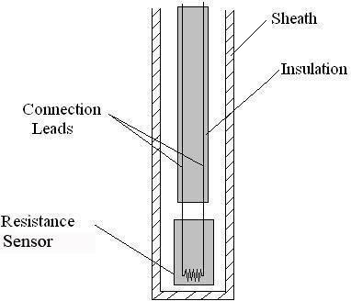

Figure 1. Schematic Diagram of Resistance Temperature Structure

As shown in Figure 1, the RTD contains an outer sheath to prevent contamination from the surrounding medium. Ideally, this sheath is composed of material that efficiently conducts heat to the resistor, but resists degradation from heat or the surrounding medium.

The resistance sensor itself is responsible for the temperature measurement, as shown in the diagram. Sensors are most commonly composed of metals, such as platinum, nickel, or copper. The material chosen for the sensor determines the range of temperatures in which the RTD could be used. For example, platinum sensors, the most common type of resistor, have a range of approximately -200°C – 800°C. (A sample of the temperature ranges and resistances for the most common resistor metals is shown in Table 1). Connected to the sensor are two insulated connection leads. These leads continue to complete the resistor circuit.

**LDR**

Light Dependent Resistor (LDR)

A Light Dependent Resistor (also known as a photoresistor or LDR) is a device whose resistivity is a function of the incident electromagnetic radiation. Hence, they are light-sensitive devices. They are also called as photoconductors, photoconductive cells or simply photocells.

They are made up of semiconductor materials that have high resistance. There are many different symbols used to indicate a photoresistor or LDR, one of the most commonly used symbol is shown in the figure below. The arrow indicates light falling on it.

Working Principle of Photoresistor (LDR)

So how exactly does a photoresistor (i.e. a light dependent resistor or LDR) work? Photoresistors work based off of the principle of photoconductivity. Photoconductivity is an optical phenomenon in which the material’s conductivity is increased when light is absorbed by the material.

When light falls i.e. when the photons fall on the device, the electrons in the valence band of the semiconductor material are excited to the conduction band. These photons in the incident light should have energy greater than the bandgap of the semiconductor material to make the electrons jump from the valence band to the conduction band.

Hence when light having enough energy strikes on the device, more and more electrons are excited to the conduction band which results in a large number of charge carriers. The result of this process is more and more current starts flowing through the device when the circuit is closed and hence it is said that the resistance

of the device has been decreased. This is the most common working principle of LDR.

Characteristics of Photoresistor (LDR)

Photoresistor LDR’s are light-dependent devices whose resistance is decreased when light falls on them and that is increased in the dark. When a light dependent resistor is kept in dark, its resistance is very high. This resistance is called as dark resistance. It can be as high as 1012 Ω and if the device is allowed to absorb light its resistance will be decreased drastically. If a constant voltage is applied to it and the intensity of light is increased the current starts increasing. The figure below shows the resistance vs. illumination curve for a particular LDR.

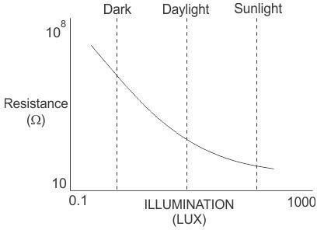

Photocells or LDR’s are nonlinear devices. Their sensitivity varies with the wavelength of light incident on them. Some photocells might not at all response to

a certain range of wavelengths. Based on the material used different cells have different spectral response curves.

When light is incident on a photocell it usually takes about 8 to 12 ms for the change in resistance to take place, while it takes one or more seconds for the resistance to rise back again to its initial value after removal of light. This phenomenon is called a resistance recovery rate. This property is used in audio compressors.

Also, LDR’s are less sensitive than photodiodes and phototransistors. (A photo diode and a photocell (LDR) are not the same, a photo-diode is a pn junction semiconductor device that converts light to electricity, whereas a photocell is a passive device, there is no pn junction in this nor it “converts” light to electricity).

Types of Light Dependent Resistors (LDRs or Photoresistors)

Photoresistors (LDRs) can be categorized into two types depending on the materials used to construct them. The two types of photoresistors include:

Intrinsic photoresistors (Undoped semiconductor): These are made of pure semiconductor materials such as silicon or germanium. Electrons get excited from valance band to conduction band when photons of enough energy fall on it and the number charge carriers are increased.

Extrinsic photoresistors: These are semiconductor materials doped with impurities which are called dopants. These dopants create new energy bands above the valence band which is filled with electrons. Hence this reduces the bandgap and less energy is required in exciting them. Extrinsic photo resistors are generally used for long wavelengths.

Applications of Photoresistors (LDRs)

Photoresistors (LDRs) have low cost and simple structure and are often used as light sensors. Other applications of photoresistors include:

Detect absences or presences of light like in a camera light meter.

Used in street lighting design (can be combined with a good Arduino starter kit to act as a street light controller)

Alarm clocks

Burglar alarm circuits Light intensity meters

Used as part of a SCADA system to perform functions such as counting the number of packages on a moving conveyor belt

### CHAPTER-6 CONCLUSION

IOT based crop field monitoring system serves as a reliable and efficient system for monitoring agricultural parameters. The corrective action can be taken. Wireless monitoring of field not only allows user to reduce the human power, but it also allows user to see accurate changes in it. It is cheaper in cost and consumes less power. The GDP per capita in agro sector can be increased. Agriculture is a backbone of human civilization since man has started agriculture. As the generation evolved, man developed many methods of crop monitoring to provide growth to the crop. In the present scenario on conservation of water is of high importance. Present work is attempts to save the natural resources available for human kind. By continuously monitoring the status of the soil, we can control the flow of water and thereby reduce the wastage. This review is proposed to supports aggressive water management for the agricultural land. Microcontroller in the system promises about increase in systems life by reducing the power consumption resulting in lower power consumption.